**DAILY ONLINE ACTIVITIES SUMMARY**

|  |  |  |  |  |  |  |  |
| --- | --- | --- | --- | --- | --- | --- | --- |
| **Date:** | **17/06/20** | | | | **Name:** | **Bhuvana S** | |
| **Sem & Sec** | **8th sem A sec** | | | | **USN:** | **4AL16CS022** | |
| **Online Test Summary** | | | | | | | |
| **Subject** | | **Not conducted** | | | | | |
| **Max. Marks** | |  | | **Score** | |  | |
| **Certification Course Summary** | | | | | | | |
| **Course** | **Angular Material :Ultimate masterclass with angular 9** | | | | | | |
| **Certificate Provider** | | | **Great Learning Academy** | **Duration** | | | **12hrs** |
| **Coding Challenges** | | | | | | | |
| **Problem Statement :Find the smallest positive integer value that cannot be represented as sum of any subset of a given array sorted in ascending order.** | | | | | | | |
| **Status: Completed** | | | | | | | |
| **Uploaded the report in Github** | | | | **Yes** | | | |
| **If yes Repository name** | | | | **bhuvanashivakumar** | | | |
| **Uploaded the report in slack** | | | | **Yes** | | | |

Online Test Details: Not conducted

Certification Course Details:

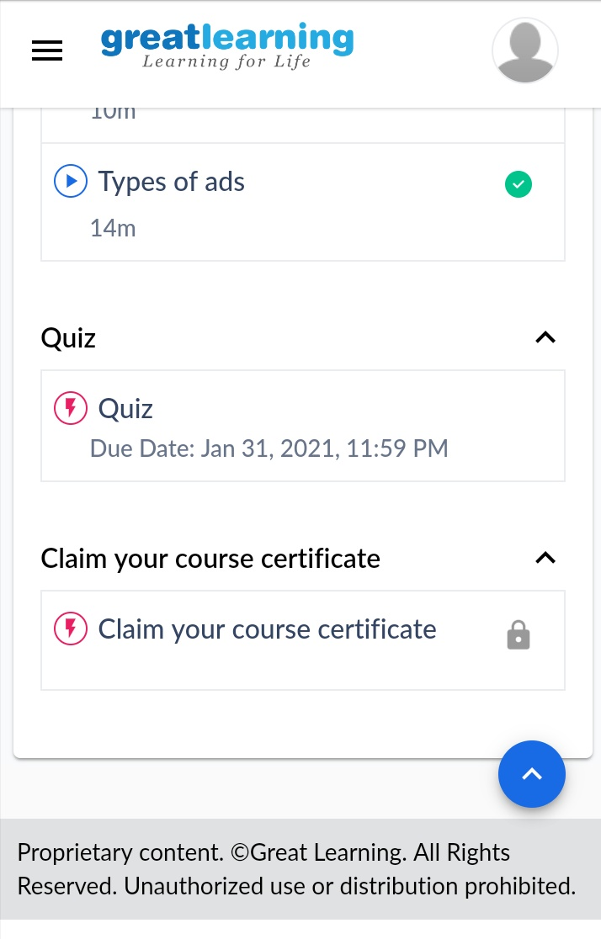

Coding Challenges Details:

|  |
| --- |
|  |
| #include <stdio.h> |
|  | int findSmallest(int arr[], int n) |
|  | { |
|  | int res = 1; |
|  |  |
|  | for (int i = 0; i < n && arr[i] <= res; i++) |
|  | res = res + arr[i]; |
|  |  |
|  | return res; |
|  | } |
|  |  |
|  | int main() |
|  | { |
|  | int arr1[100],n ; |
|  | printf("n :"); |
|  | scanf("%d",&n); |
|  | printf("array :"); |
|  | for(int i=0;i<n;i++){ |
|  | scanf("%d",&arr1[i]); |
|  | } |
|  | printf("There are no elements to get sum = %d",findSmallest(arr1, n)); |
|  |  |
|  |  |
|  | return 0; |
|  | } |
|  |  |